How to Publish Laravel App in Linux Server

Step 1

Connect to Putty using your credentials. Ex.

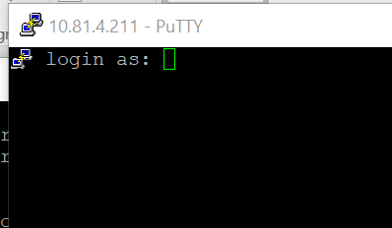

Step 2

Clone the application using git command.



**Problem Encountered below.**

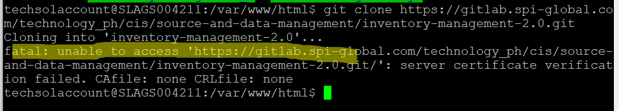

**Solution 1:**

Run this command and provide gitlab credentials.



Step 3

Go to app root folder using this command “cd AppName”.



Step 4

Run composer command below.

Composer update

Error

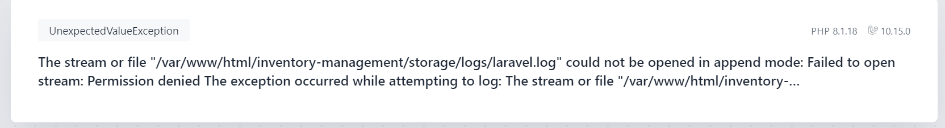

Solution

Run this command:

sudo chmod -R 777 /var/www/html/inventory-management